1. **Agenda**:
   1. How Spring Boot autoconfigures the **KafkaTemplate** by reading the configurations from application.yaml file.
2. 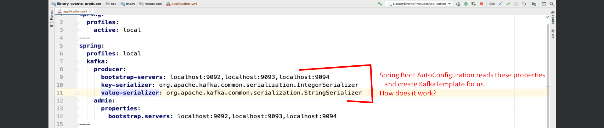
3. Search for the following jar in dependency section.   
   
4. 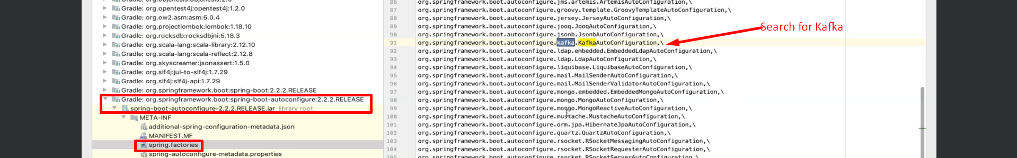  
   This is the class that reads application.yaml file and read those properties and create KafkaTemplate for us.
5. Let’s open this class 🡺 **KafkaAutoConfiguration.java**
6.   
     
   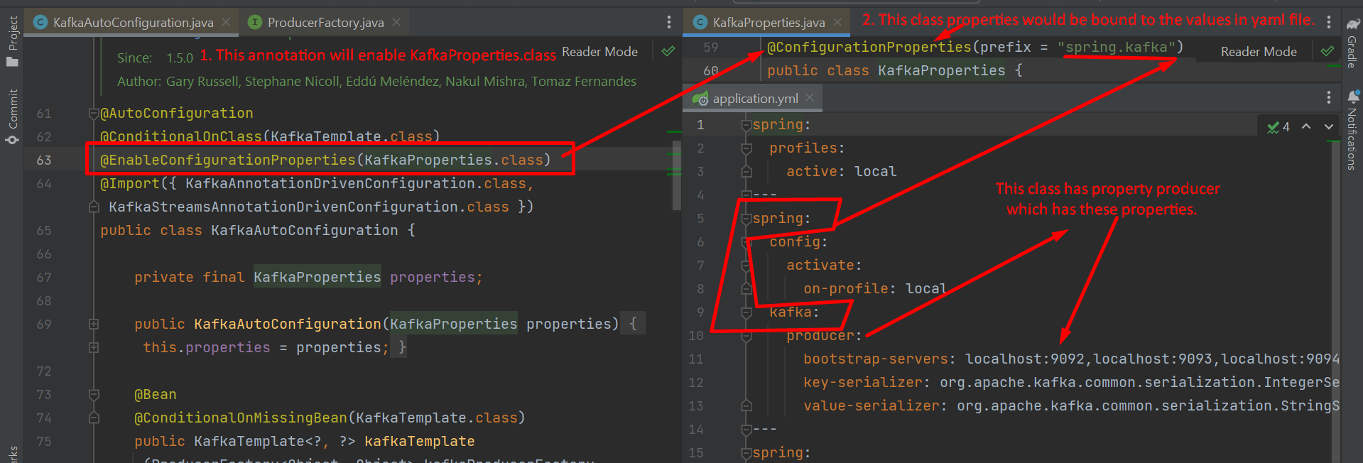  
     
     
   In the following snapshot, the method kafkaTemplate(…) takes 3 objects.   
   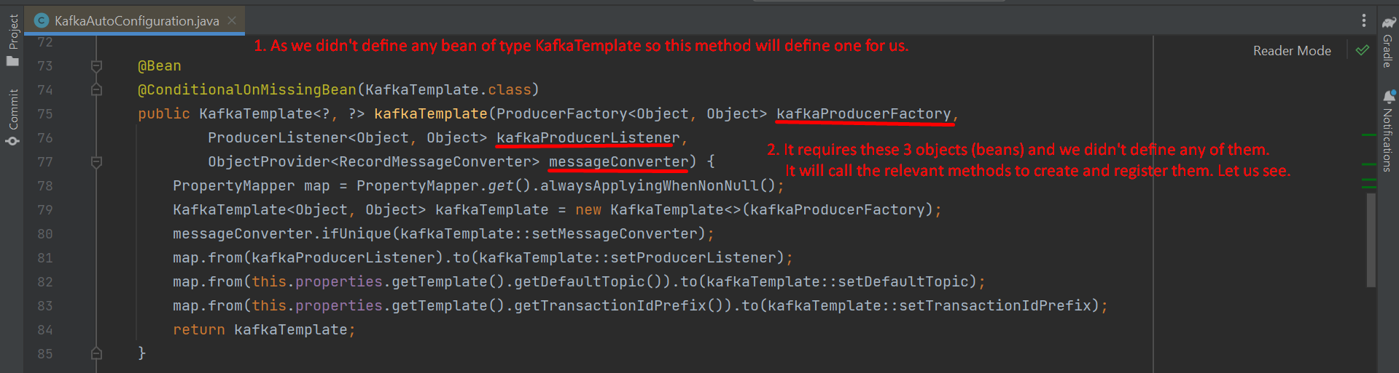  
     
   **1st Object**: Creating **DefaultKafkaProducerFactory** as we didn’t define any.   
   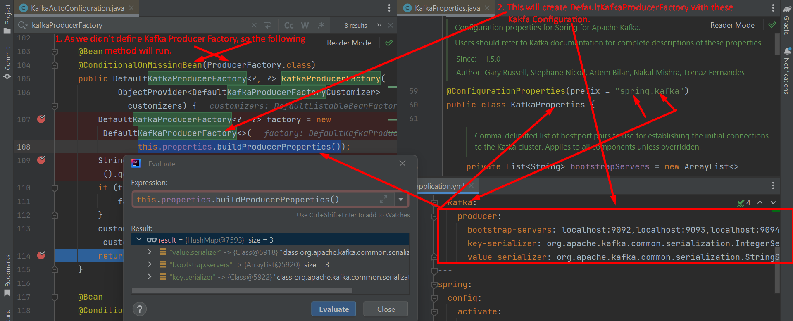  
     
     
   **2nd Object**:  
     
     
   **3rd Object**:   
   As we didn’t define any Message Converter, so default one will be used.

1. In nutshell, what we discussed here is that whatever properties we configured in application.yaml file for Kafka Producer, “**Spring Boot Auto Configuration**” is going to read them and create a Spring Kafka Template for us.